[ITI41120 Applied Computer Science Project](https://www.hiof.no/english/studies/courses/iio/itk/2023/spring/iti41120.html" \t "_blank)

**Topic:** Enablingautonomous control of a scaled vehicle

**Research areas involved:** Cyber-Physical systems, Machine Learning, Image Processing

**Required:** experience with Raspberry Pi, Arduino, Nvidia Jetson or similar;

**Beneficial:** familiarity with autonomous navigation, Image Processing, ROS, or Machine Learning

**Contacts:** Jens-Patrick Langstrand (jplangst@hiof.no), Maben Rabi (maben.rabi@hiof.no)

**Content:** This is an experimental project that involves two parts:

1. Enabling autonomous control of an F1-10 hobby vehicle

* Collect sensory information from on-board IMU sensors and a depth camera mounted on the scaled vehicle
* Design and implementation of a vehicle control algorithm that takes the sensory information as input and output vehicle commands so that the vehicle can follow curved road sections at commanded speeds
* Collect kinematic records as the vehicle drive through the indoor track

1. Estimation of unmeasurable vehicle signals, safe speed and coefficient of friction

* From the records estimate signals that indicate whether the vehicle behaved as intended by the control algorithm, such as the difference between intended (acceleration, rotation and direction of travel) and what is measured by the sensors.
* Possibly include an external camera so that the vehicle motion can be recorded for ground truth purposes
* Applying standard Machine learning methods such as, Random forests, SVM regression etc. to estimate (a) the safe speed for a given curve, and (b) the coefficient of friction between the tyres and the road surface

The indoor track

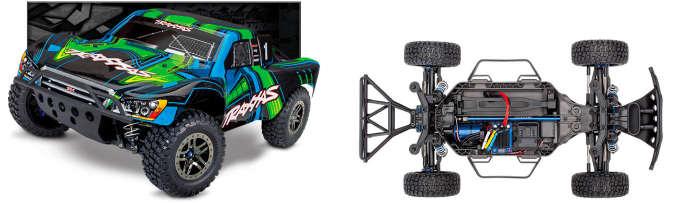

The scaled vehicle F1-10